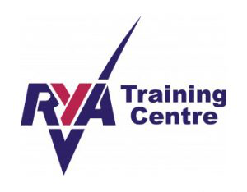
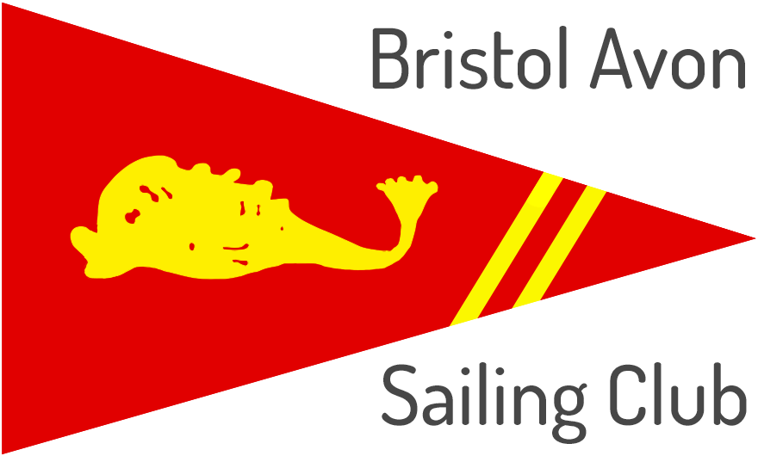
Bristol Avon Sailing Club
Learn to Sail Membership Packages 2022
We are not a commercial sailing school, but we do offer training to bring in new members who wish to be part of and contribute to the future success of our club.
To do this, we have a have a team of volunteer members who are qualified RYA Dinghy Instructors who offer their time for free enabling us to keep our prices affordable.
The training is suitable for new members to the club who have never sailed before or who have sailed before but need to refresh their skills.
To simplify pricing, we offer a membership with training bundle that includes either adult, youth or junior training plus club membership from the start of the course to the end of November 2022.

Includes:
- Training as described below
- Free use of club boats during the training course and afterwards up to and including the club’s regatta in July
- RYA Training Logbook and RYA Start Sailing Theory book
- Opportunity for further mentoring / training
- 15% discount on membership renewal for 2023

Pre-Course Requirements
The trainee must:
- Have their own buoyancy aid – this is important for your safety!
- Be a confident swimmer – dinghy sailing involves capsizing which is part of the fun!
- Be in good health – if in doubt ask!
 | Dates | Time* | Adults | Juniors***
Pre-Course Meeting | Thurs 12th May | 19:00 – 20:00 | All to attend
Weekend 1** | Sat 14th May | 09:00 – 17:00 | RYA Level 1 | RYA Stage 1
 | Sun 15th May | 09:00 – 17:00 | RYA Level 1 | RYA Stage 1
Weekend 2** | Sat 21st May | 09:00 – 17:00 | RYA Level 2 | RYA Stage 2
 | Sun 22nd May | 09:00 - 17:00 | RYA Level 2 | RYA Stage 2
Contingency Day | Sat 11th June | 09:00 - 17:00 | As required
* Finishing times for Juniors may be earlier so please check with the instructor on the day.
** In the event that one or more days in Weekend 1 or 2 need to be cancelled due to severe weather or high river flow rates they will be re-scheduled on subsequent Saturdays/Sundays and the contingency day used.
** Parents/Guardians are not required to stay during the training but must accompany juniors at all other times when on club premises.

Example Prices (see application form for full details)

Adult Learn to Sail Package: £320
- RYA Level 1 & 2 Training & BASC membership for one adult

Joint Adult Learn to Sail Package: £550
- RYA Level 1 & 2 Training & BASC membership for two adults who share an address

Junior Learn to Sail Package: £180 (recommended age: 10-14 years)
- RYA Junior Stage 1 & 2 Training
- Includes BASC membership for 1 non-sailing adult (who will act as a guardian) and 1 junior up to 18 years old.

Youth Learn to Sail Package: £278 (recommended age: 15-18 years)
- RYA Adult Level 1 & 2 Training
- Includes BASC membership for 1 non-sailing adult (who will act as a guardian) and 1 junior up to 18 years old.

To reserve a place or for more information please contact:
Caroline Howard - Membership Secretary
Email: membershipsecretary@bristol-avon-sailing.org.uk

