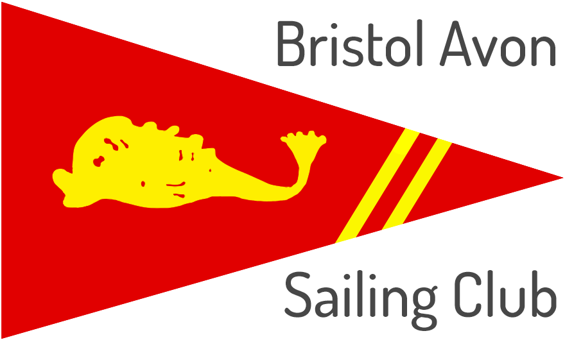
Bristol Avon Sailing Club
Application for Learn to Sail Membership
Mead Lane
Saltford
Bristol
BS31 3ER
Please email completed form to membershipsecretary@bristol-avon-sailing.org.uk

The following fees cover
- Membership from 1st May to 30th November 2022
- RYA Training Course (Adult Level 1 & 2 or Junior Stage 1 & 2) on
  - 14th & 15th May 2022
  - 21st & 22nd May 2022
  - 11th June 2022 (this will only be required if any of the above days is cancelled)
Applicant Details (for Adult/Joint/Guardian/Student):
Title: ……………… Surname: ……………………………………………….. First Name(s): ………………….…….………………………………
Address: ….…………………………………………………………………………………………….……………………………….…………………………..
……………………………………………………………………………………………….……………... Post Code: .……..………………….…………..
Home Tel: ………..………..………………………….....………… Mobile: …..…………………..……………………………………………….……
E-mail address: ………………………………………………………………………………………………………………………………………….………..
Occupation: …………………………………………………………………………………………………………………………………………………………
Student Member’s Course Title & End Date*: …….………………………………………………… Student DOB* ….../….../…...
Partner Details (for Joint Adult only):
Title: …………… Surname: ………………………………………..……….. First Name(s): ………………….….………………………………….
E-mail address: …………………………………………………….………………… Mobile: …………………………………………………………….
Names and Dates of Birth of Junior or Youth Members:
Child 1: ……..…………………………………….. DOB …../…../….. Child 2: ……….………….………………………… DOB …../…../…..
Child 3: ……………………………………………. DOB .…./…../….. Child 4: ………………….………………..…..…… DOB …../…../…..
Boat Details**:
Class: ………………………………………………………….….. Name: ……………………………………… Sail/Hull No: …………………………
Please enter the quantity for each type of membership/training package required and the total value in the “Total” column and then complete the “Total Payable on Application” at the bottom.
Membership & Training Type |  |  | Cost Each | Qty | Total
A | Adult |  | £320
B | Adult + 1 Junior |  | £398
C | Joint Adult |  | £550
D | 1 Junior (includes 1 Guardian) |  | £180
E | 2 Juniors (includes 1 Guardian) |  | £224
F | Additional Junior (adder to A-E) |  | £120
G | Youth (includes 1 Guardian) |  | £269
H | Student ¹ |  | £247
Extras
Dinghy Space for 1 Boat ² |  |  | £36.00
River Licence ³ |  |  | £18.00
Total Payable on Application |  |  |  |  | £
Notes:
* Only complete if applying for Student membership plus training
** Only complete if you already have your own dinghy and wish to keep it in the dinghy park
1 For persons aged 18-25 who are in full time education.
2 All dinghy owners who have registered boats at BASC must hold a valid and current insurance including third party liability to £2,000,000 that covers them while sailing. Production of this document may be requested at any time.
3 All boats that sail on the River Avon need to be licensed with the Canal & River Trust.
Terms and Conditions
The following notes form part of the application and by signing you are giving your agreement. Please read these carefully and then complete the Payment/Signature section at the bottom.
Cancellation Policy
Up to 1st March 2022: Membership and training fees will be refunded in full.
1st March to 30th April 2022: Membership fees will be refunded in full.
Training fees will not be refunded unless we are able to find someone to fill the place(s) on the course.
Training Course Dates
Training course dates are fixed and trainees must ensure that they are able to attend all dates including the contingency date. In exceptional circumstance e.g. global pandemic rules or extreme weather events it may not be possible to run the training on one or more of the arranged dates. In these circumstances, new dates will be arranged in consultation with the trainees.
Attendance
Trainees must attend all days to be eligible for the relevant RYA qualification, the award of which will depend on the level achieved by the trainee at the end of the course and will be at the discretion of the Senior Instructor.
Duties
ALL members are REQUIRED to assist in the running of the Club by undertaking at least one of the following tasks:
- Race Officer or Assistant,
- Safety Boat Helm or Assistant
- Duty Officer
Members are expected to carry out at least 3 duties during the year. You will not be asked to carry out any duty without first receiving the appropriate training. Under no circumstances will you be asked to carry out a duty that you believe beyond your capabilities.
Sanctions will be imposed upon anyone who refuses to carry out a duty or who persistently ‘forgets’ to turn up.
Junior / Youth Members
Parents and guardians are warned that the Club is only able to provide rescue facilities during the hours of Club racing or prescribed sailing periods (e.g. training courses or social sailing). Outside these hours, parents and guardians have sole responsibility for their children and wards and, regrettably, the Club cannot provide supervision or control of junior / youth members at any time. Even during club racing, the Club cannot accept responsibility for children or any other person not engaged in racing.
The Club has a Child Protection Policy in line with the RYA. From time to time, at special events and during training, photographs and videos may be taken for use in the Club’s newsletter and training videos. Please indicate below if you agree or disagree with this.
Galley Facilities
Tea, coffee, squash & biscuits for members are included in the above membership fees. Additional items are available for purchase and an honesty box is provided for such purchases and for the purchase of refreshments for guests.
Payment/Signature
I enclose cheque / cash for £………………… (cheques payable to Bristol Avon Sailing Club)
I have arranged payment via bank transfer:
Name of Account: Bristol Avon Sailing Club
Account Number : 01789190
Sort Code: 30-00-01
Reference: Your surname

- I/We agree to the Club holding my membership details on computer provided that the information held will only be used for the purpose of club administration and will not be passed to any outside agency.
- I/We agree to abide by the rules of Bristol Avon Sailing Club, and to undertake the duties allocated.
- As parent/guardian to the junior member(s) named above, I agree to be responsible for them at all times.
- As a parent /guardian I agree / I do not agree to them being photographed for Club use only.

Applicant Signature: …………………………………………………………………………………………..…… Date: ………………………
Partner Signature: ……………………………………………………………………………………………..…… Date: ………………………
If the applicant is under 18 years of age, the above must be signed by the member acting as guardian
Name of existing member acting as guardian for the junior applicant: ………………………………………………………………………….
For Completion by Club
Proposed by: …………………………………………………………………………………… Print Name: ………………………………………………………………
Seconded by: …………………………………………………………………………………… Print Name: ………………………………………………………………

